**LAB ASSIGNMENT – 7.3**

**NAME :** KARTHIK RAM .D

**HALL.NO :** 2403A52384

**BATCH.NO :** AI 14

**PLATFORM USED :** GOOGLE COLLAB AND perplexity.ai

**PROMPT 01 :**

def add(a, b):

return a + b

correct this code by fixing the syntax :

**OUTPUT :**

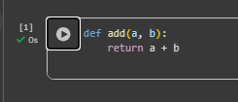

**CODE CORRECTION EXPLANATION :**

* Add a colon after the function header to start the code block: def add(a, b): is the correct header.
* Indent the next line to form the function body; the return statement must be inside the block.
* Final corrected code:

python

def add(a, b):

return a + b

* Missing the colon causes a SyntaxError; wrong or missing indentation triggers an IndentationError.

**PROMPT 02 :**

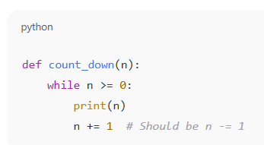

Identify and fix a logic error in a loop that causes infinite iteration.

**OUTPUT :**

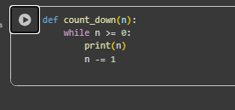

**CODE CORRECTION EXPLANATION :**

* The loop condition is n >= 0, so n must move downward each iteration to eventually become less than 0 and stop.
* The original code used n += 1, which increases n and keeps the condition true, causing an infinite loop.
* Replace n += 1 with n -= 1 so n decreases toward −1 and the loop terminates correctly.

**PROMPT 03 :**

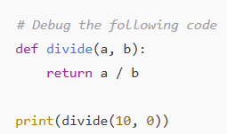

fix the Debug a runtime error caused by division by zero

**OUTPUT :**

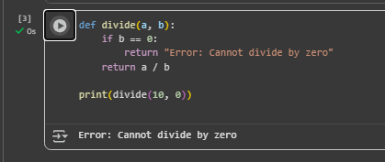

**CODE CORRECTION EXPLANATION :**

* Division by zero is undefined in Python and raises ZeroDivisionError at runtime.
* Fix by validating input first: if b == 0, handle it and skip division.
* Alternative: wrap the operation in try/except to catch ZeroDivisionError and recover gracefully.

**PROMPT 04 :**

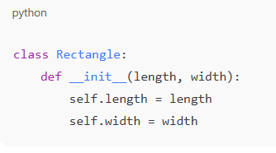

YOU NEED TO Provide a faulty class definition (missing self in parameters)

**OUTPUT :**

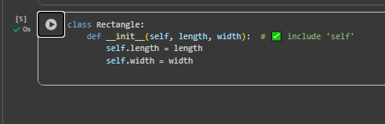

**CODE CORRECTION EXPLANATION :**

* The constructor was missing the first parameter self, which is the reference to the instance Python automatically passes to instance methods.
* Without self, calling Rectangle(5, 3) raises “TypeError: init() missing 1 required positional argument: 'self'”.
* Fix by adding self as the first parameter and using it to set attributes:

**PROMPT 05 :**

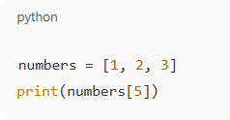

resolve the Index Error Access an invalid list index.

**OUTPUT :**

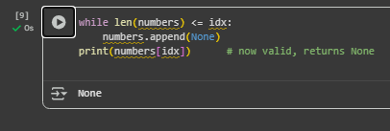

**CODE CORRECTION EXPLANATION :**

* Valid indices for are 0, 1, 2; 5 is out of range.
* Fix by choosing an existing index or by checking bounds with len before access.
* When adding elements, use append or insert instead of assigning to a non‑existent index.